**DESIGNING A SALES DASHBOARD IN EXCEL**

Filed by

JAGADEESWARAN A B

(Business Analyst)

Simplilearn EXCEL project I

**1. Create a database named employee, then import data_science_team.csv proj_table.csv and emp_record_table.csv into the employee database from the given resources.**

**Query: (to create database)**

create database employee;

use employee;

**Action performed:**

Import emp_record_table into employee database using “Table data import wizard” option

**Query: (to describe employee record table)**

desc emp_record_table;

**Output:**

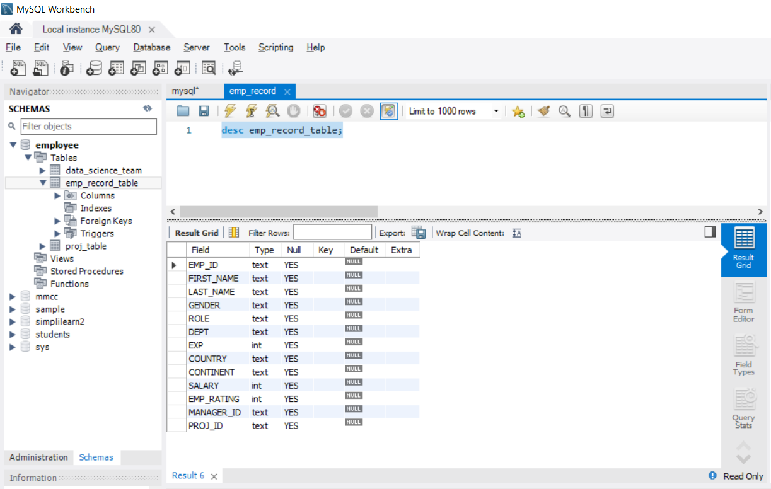

**Query: (to create and describe project table)**

create table proj_table

(

project_id varchar(255) not null,

proj_name varchar(255) not null,

domain varchar(255) not null,

start_date date,

closure_date date,

dev_qtr varchar(255) not null,

proj_status varchar(255) not null,

primary key(project_id)

);

desc proj_table;

**Output:**

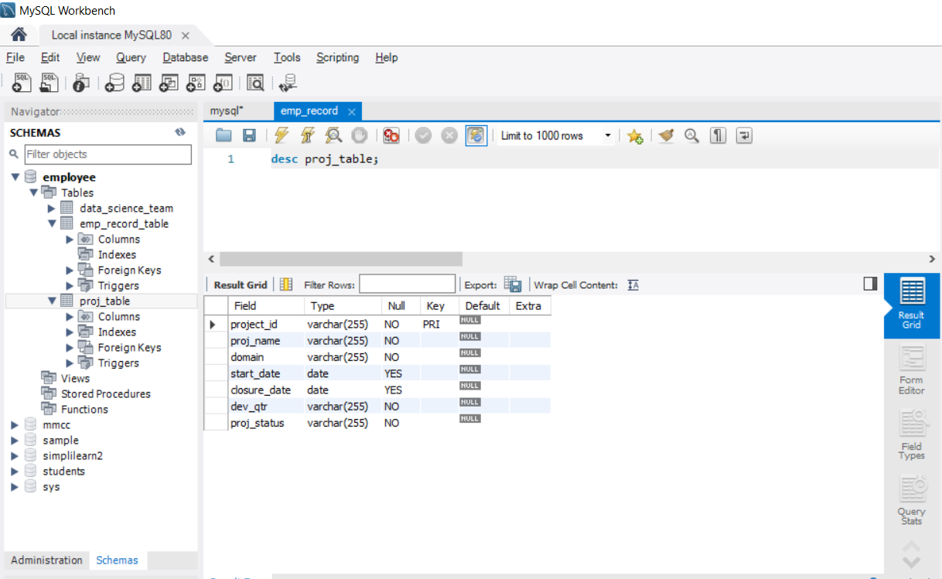

**Query: (to create and describe data science team table)**

create table data_science_team

(

emp_id varchar(255) not null,

first_name varchar(255) not null,

last_name varchar(255) not null,

gender varchar(255) not null,

emp_role varchar(255) not null,

emp_dept varchar(255) not null,

emp_exp int(20) not null,

country varchar(255) not null,

continent varchar(255) not null

);

desc data_science_team;

**Output:**

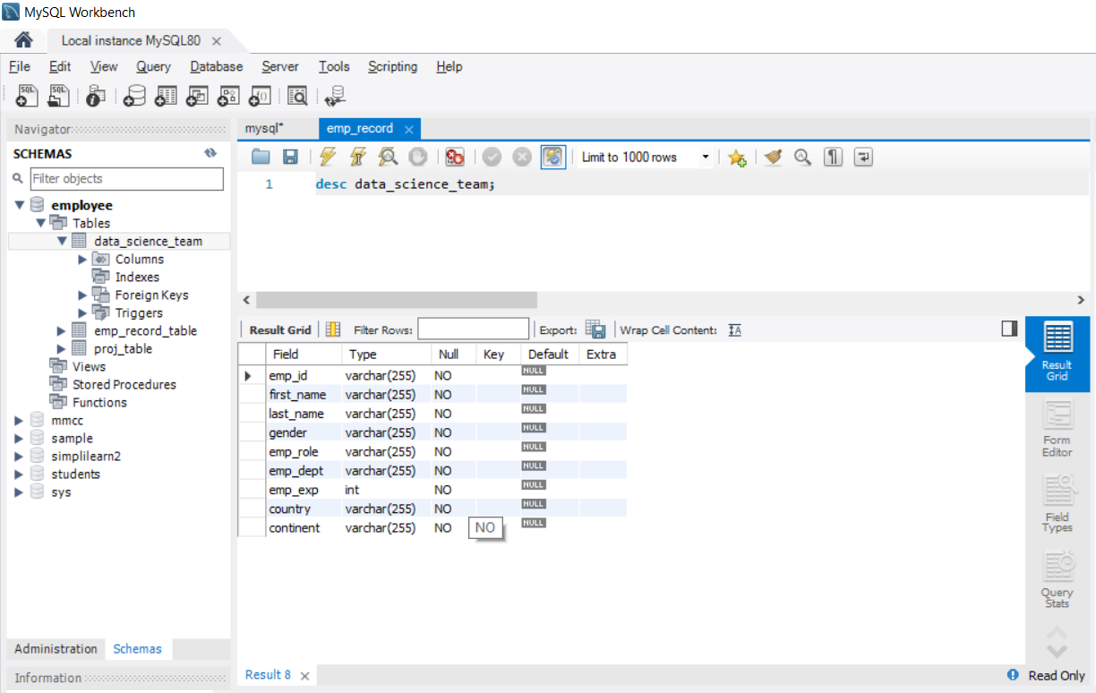

2.Create an ER diagram for the given employee database.

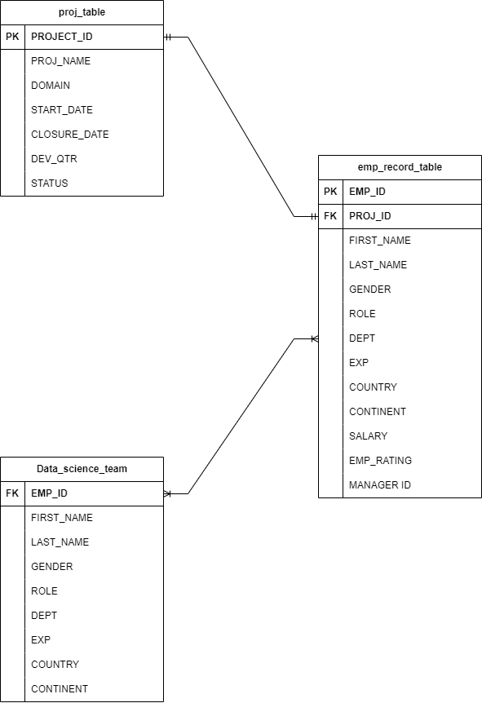

3.Write a query to fetch EMP_ID, FIRST_NAME, LAST_NAME, GENDER, and DEPARTMENT from the employee record table, and make a list of employees and details of their department.

select EMP_ID, FIRST_NAME, LAST_NAME, GENDER, DEPT from emp_record_table;

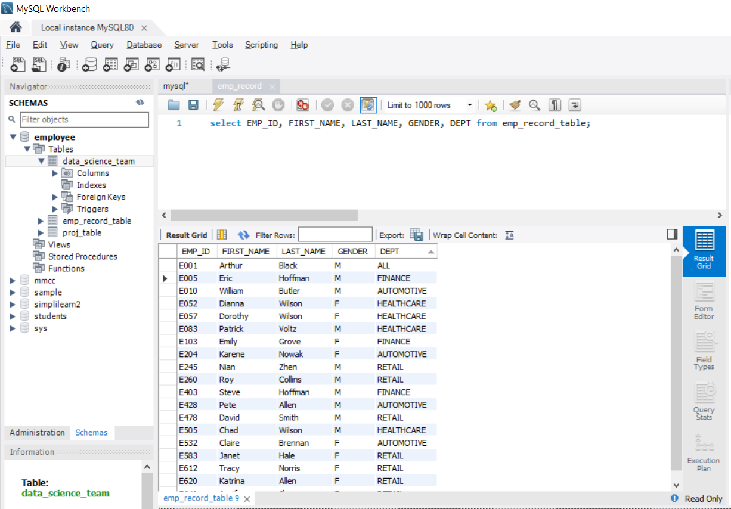

4. Write a query to fetch EMP_ID, FIRST_NAME, LAST_NAME, GENDER, DEPARTMENT, and EMP_RATING if the EMP_RATING is:

->less than two

select EMP_ID, FIRST_NAME, LAST_NAME, GENDER, DEPT, EMP_RATING from emp_record_table where EMP_RATING < 2;

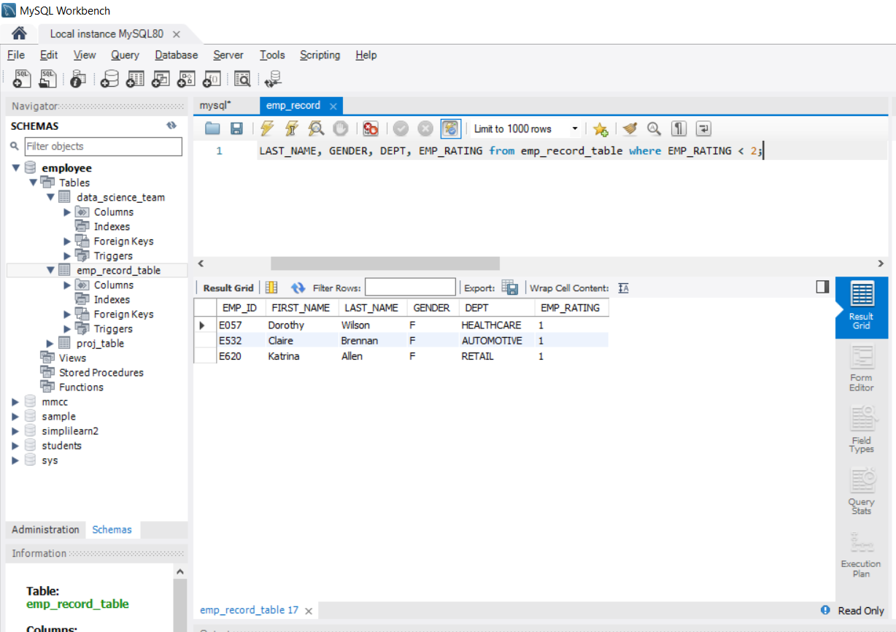

->greater than four

select EMP_ID, FIRST_NAME, LAST_NAME, GENDER, DEPT, EMP_RATING from emp_record_table where EMP_RATING > 4;

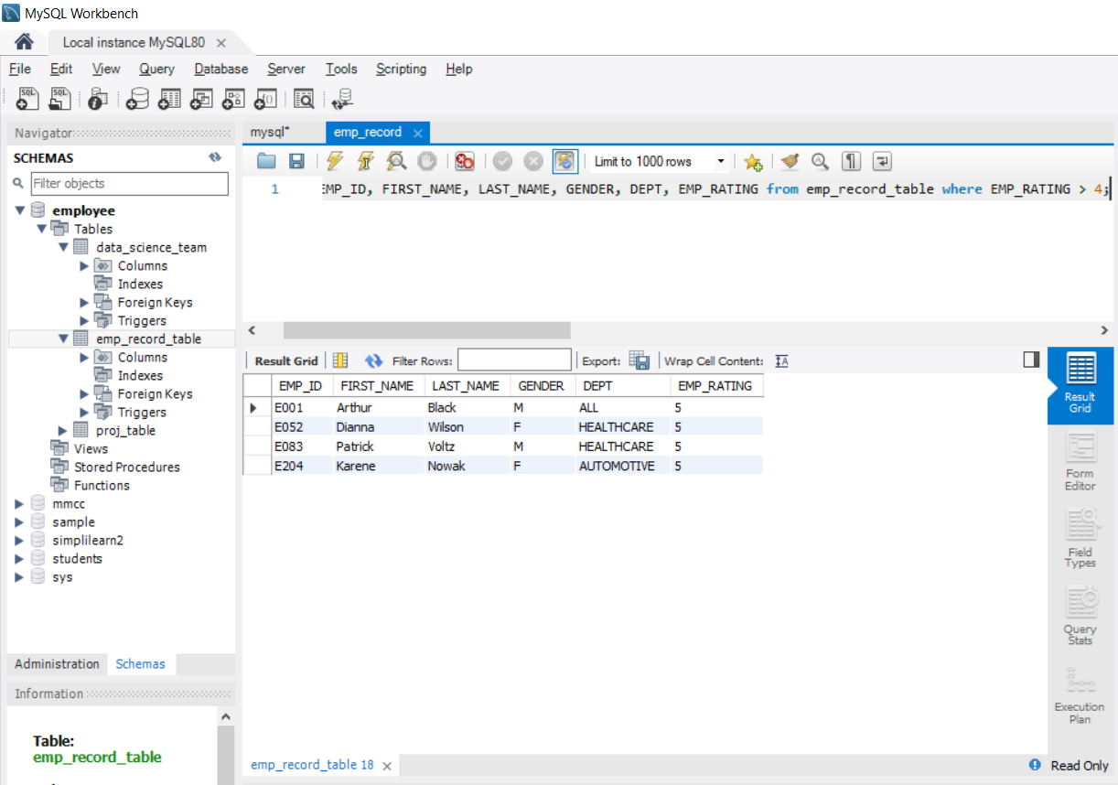

->between two and four

select EMP_ID, FIRST_NAME, LAST_NAME, GENDER, DEPT, EMP_RATING from emp_record_table where EMP_RATING > 2 and EMP_RATING < 4;

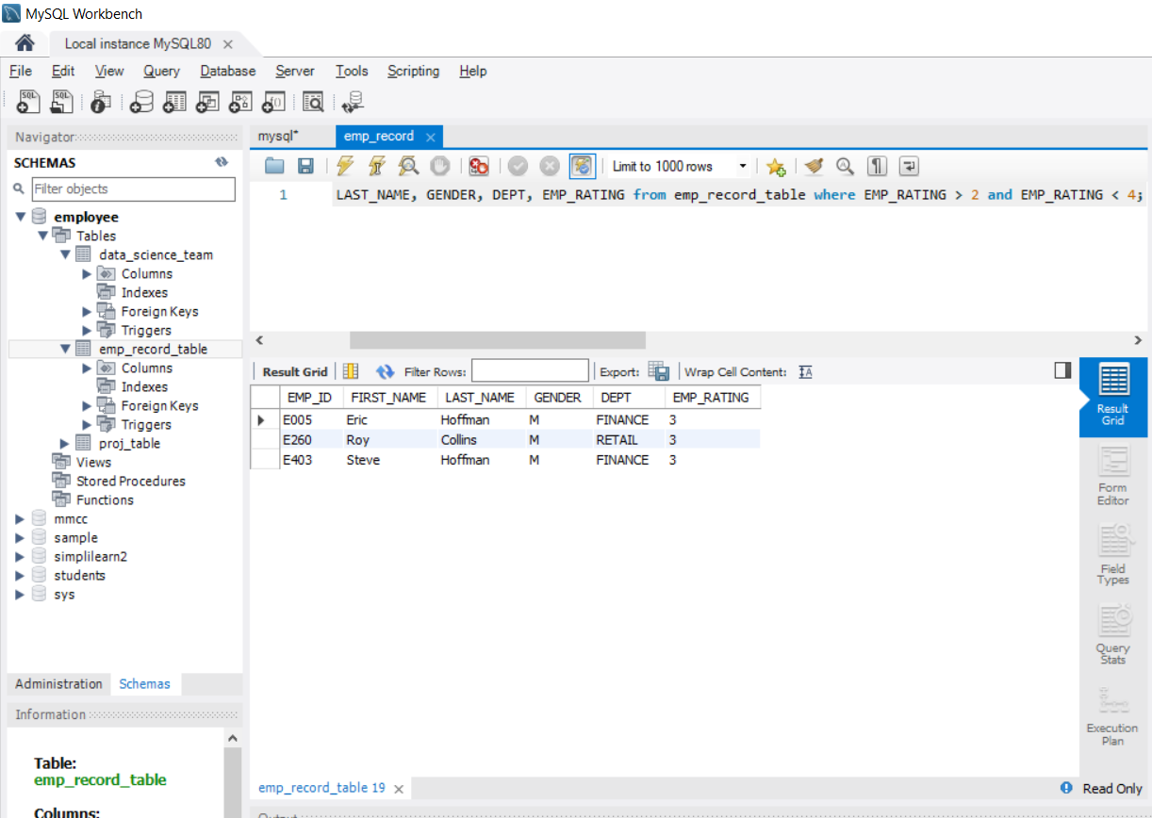

5.Write a query to concatenate the FIRST_NAME and the LAST_NAME of employees in the Finance department from the employee table and then give the resultant column alias as NAME.

select *, concat(FIRST_NAME," ",LAST_NAME) as FULL_NAME from emp_record_table where DEPT = 'FINANCE' ;

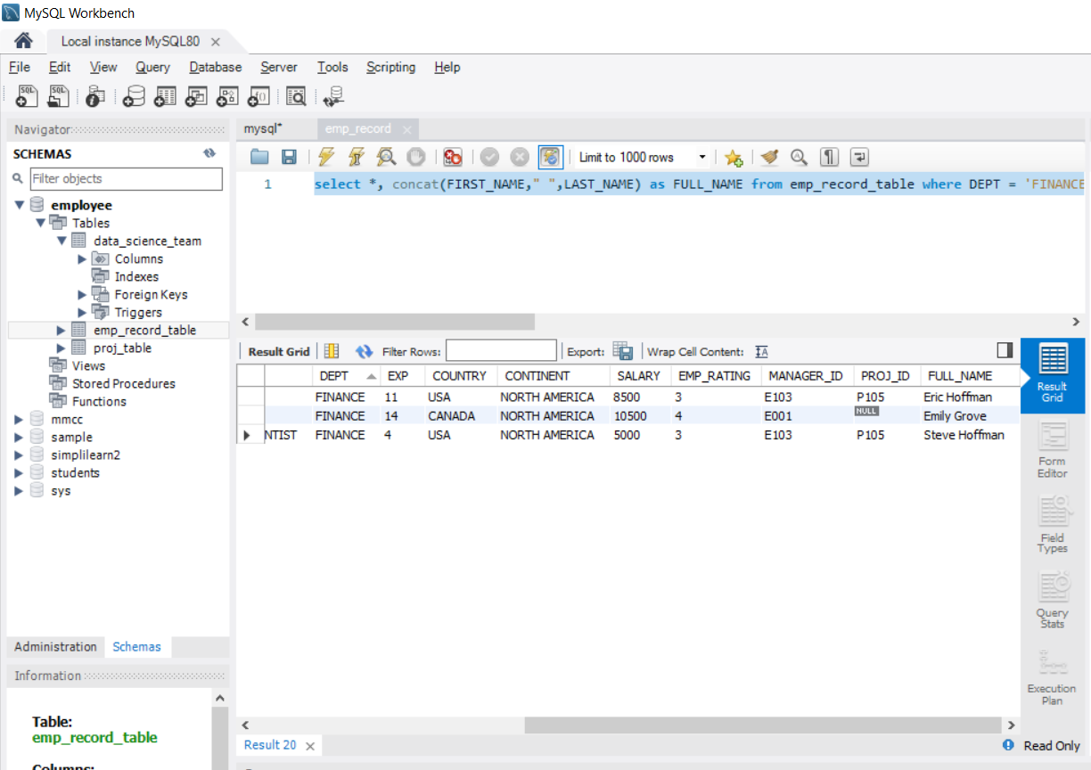

6.Write a query to list only those employees who have someone reporting to them. Also, show the number of reporters (including the President).

select Concat(FIRST_NAME," ",LAST_NAME) as EMP_NAME, MANAGER_ID, count(MANAGER_ID) AS Num_of_emp_reporting from emp_record_table GROUP BY MANAGER_ID ORDER BY Num_of_emp_reporting DESC;

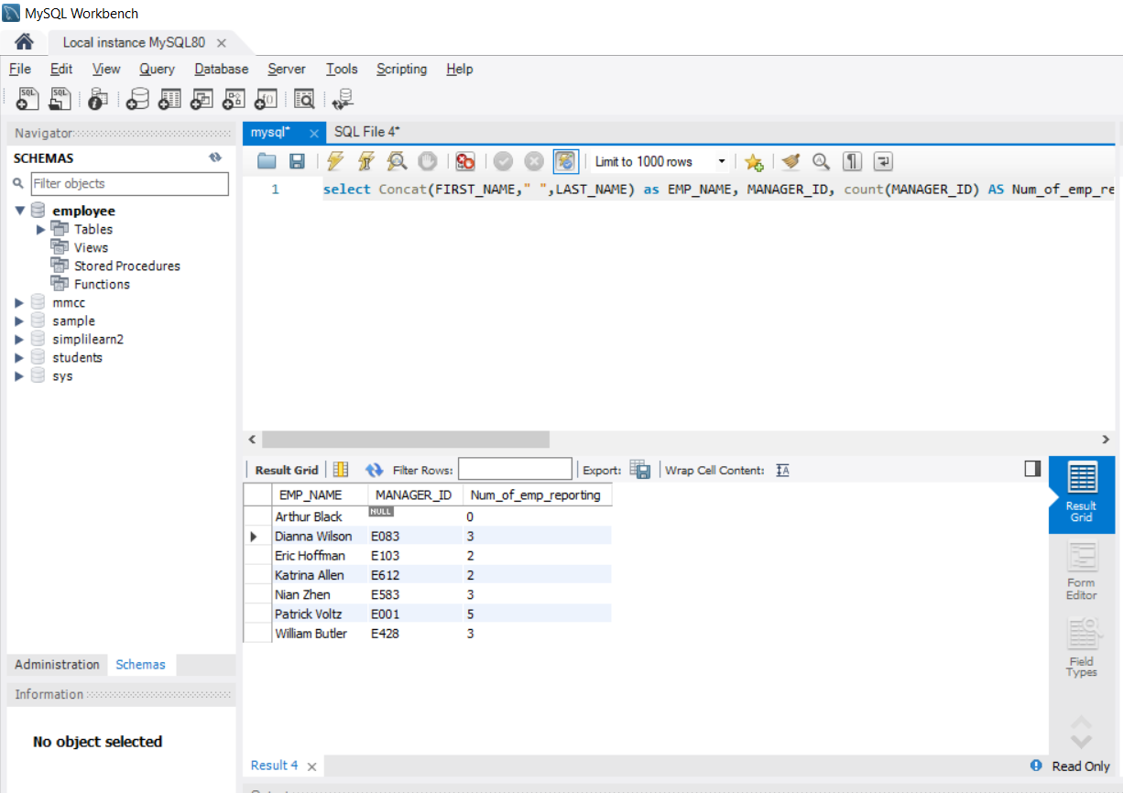

7.Write a query to list down all the employees from the healthcare and finance departments using union. Take data from the employee record table.

select concat(FIRST_NAME, " ", LAST_NAME) as FULL_NAME, DEPT from emp_record_table where DEPT = 'HEALTHCARE'

union

select concat(FIRST_NAME, " ", LAST_NAME) as FULL_NAME, DEPT from emp_record_table where DEPT = 'FINANCE';

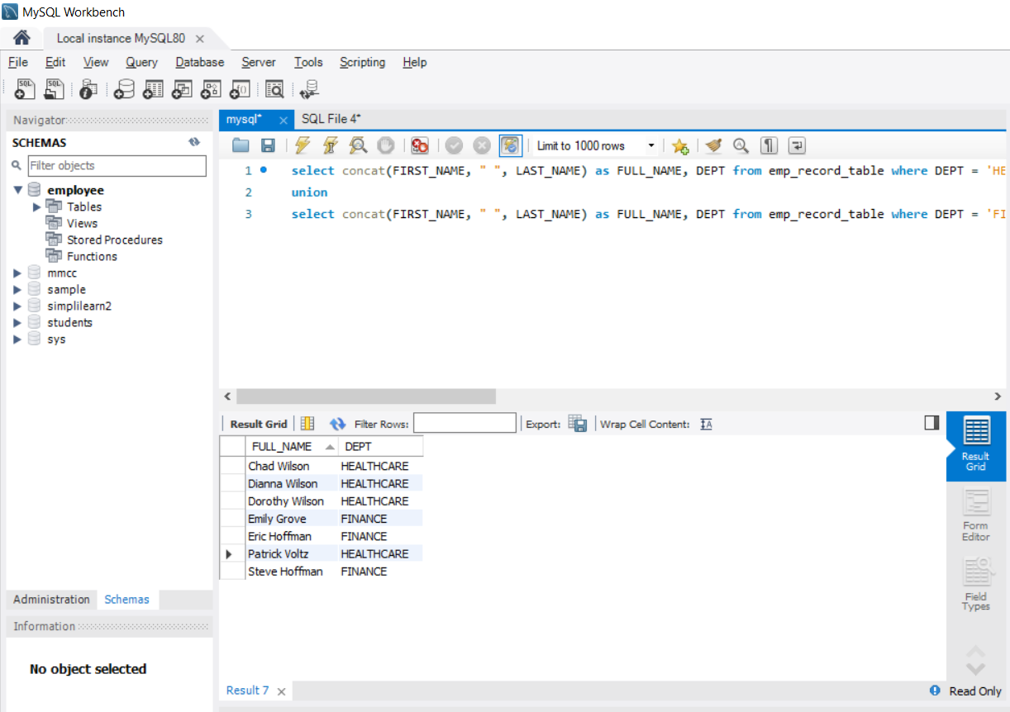

8.Write a query to list down employee details such as EMP_ID, FIRST_NAME, LAST_NAME, ROLE, DEPARTMENT, and EMP_RATING grouped by dept. Also include the respective employee rating along with the max emp rating for the department.

select EMP_ID, concat(FIRST_NAME," ",LAST_NAME) AS FULL_NAME, ROLE, DEPT, max(EMP_RATING) as max_emp_rating from (select EMP_ID, FIRST_NAME, LAST_NAME, ROLE, DEPT, EMP_RATING from emp_record_table order by DEPT) temptable group by DEPT;

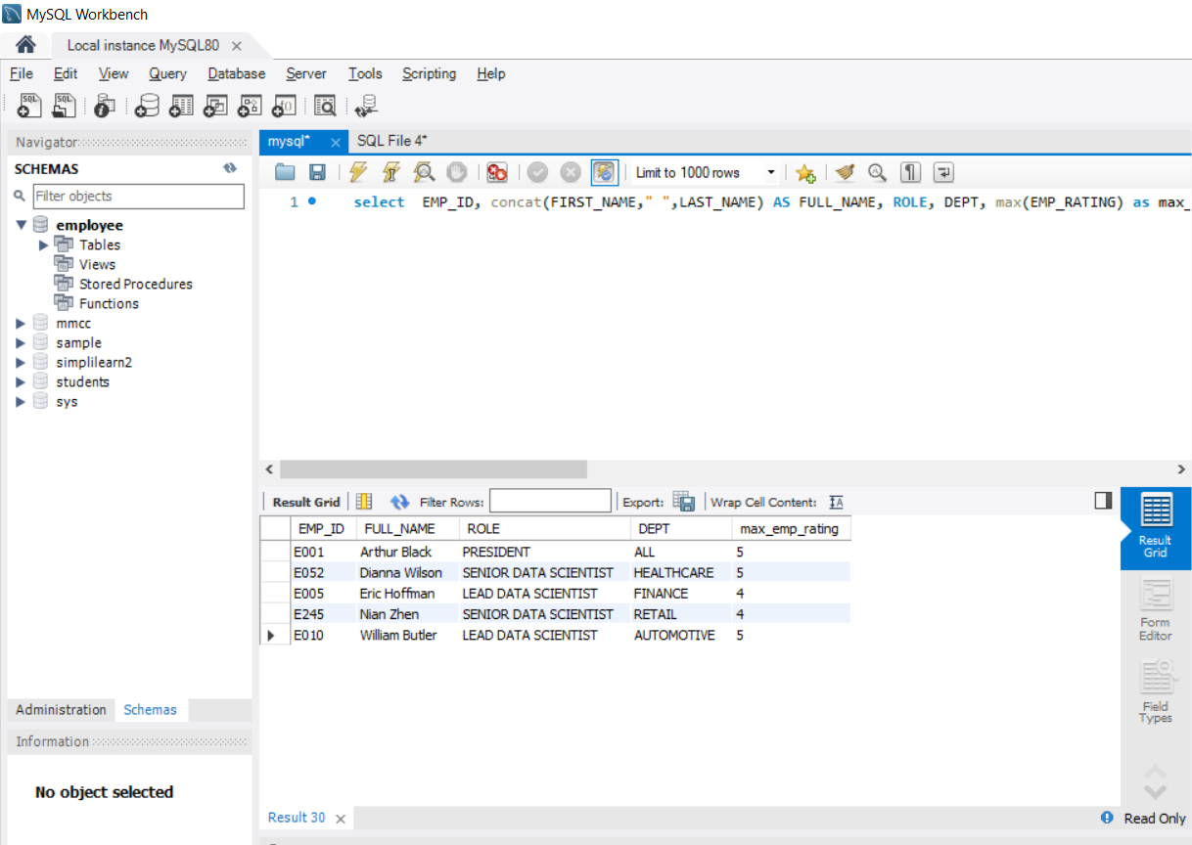

9.Write a query to calculate the minimum and the maximum salary of the employees in each role. Take data from the employee record table.

select ROLE, min(SALARY) as Minimum_salary, max(SALARY) as Maximum_salary from emp_record_table group by ROLE;

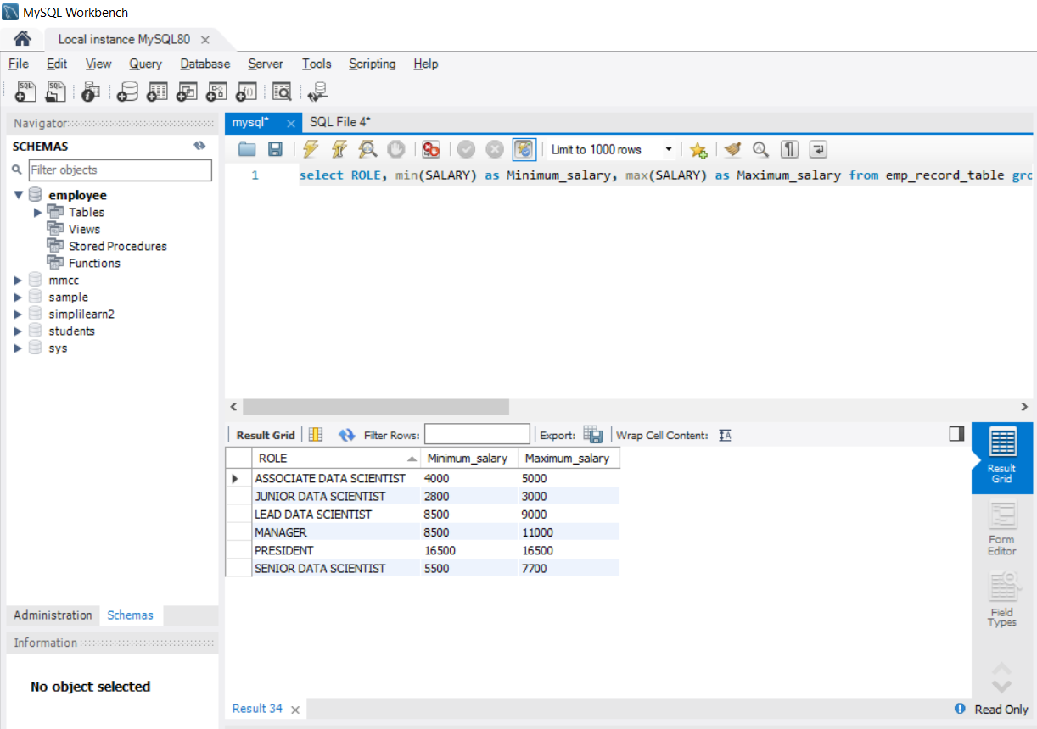

10.Write a query to assign ranks to each employee based on their experience. Take data from the employee record table.

select EMP_ID, CONCAT(FIRST_NAME," ", LAST_NAME) AS EMP_NAME, ROLE, DEPT, DENSE_RANK() OVER (order by EXP desc) as Rank_of_emp from emp_record_table;

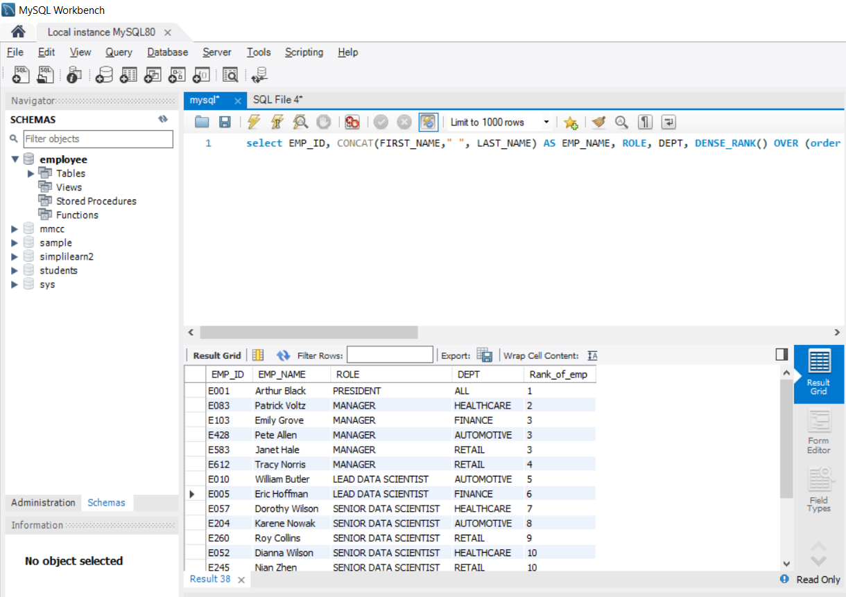

11.Write a query to create a view that displays employees in various countries whose salary is more than six thousand. Take data from the employee record table.

create view salary_more as select EMP_ID, concat(FIRST_NAME," ", LAST_NAME) as FULL_NAME, ROLE, DEPT, COUNTRY, SALARY from emp_record_table where salary > 6000 order by SALARY;

select * from salary_more;

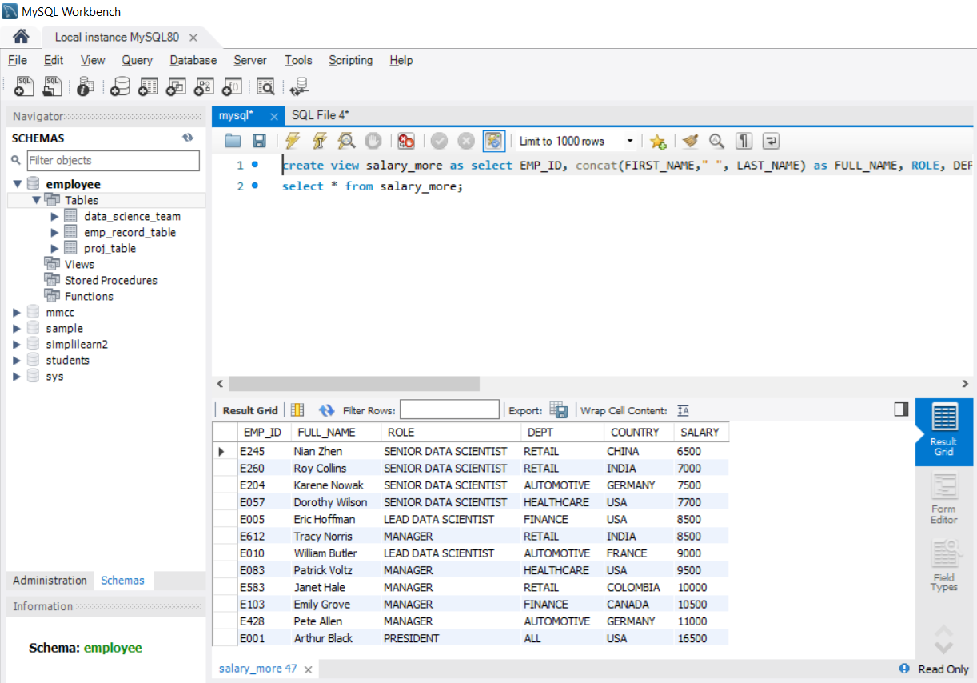

12.Write a nested query to find employees with experience of more than ten years. Take data from the employee record table.

select * from (select EMP_ID, concat(FIRST_NAME," ", LAST_NAME) as FULL_NAME, ROLE, DEPT, EXP, SALARY from emp_record_table) temptable where EXP > 10 order by EXP desc;

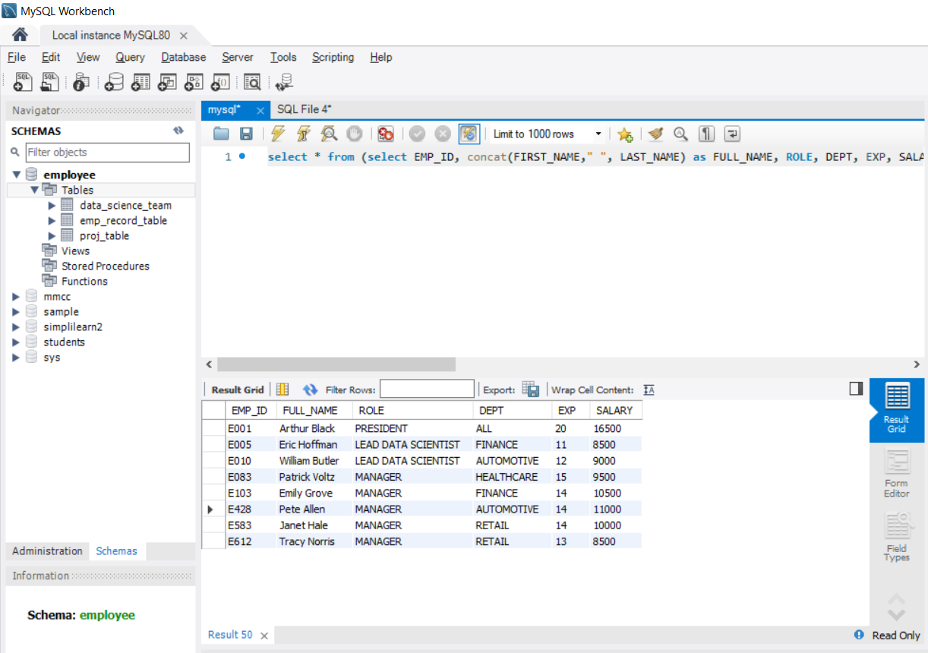

13.Write a query to create a stored procedure to retrieve the details of the employees whose experience is more than three years. Take data from the employee record table.

STORED PROCEDURE

==================

CREATE DEFINER=`root`@`localhost` PROCEDURE `Employee_exp`(in EXP int)

BEGIN

select * from emp_record_table where emp_record_table.EXP > EXP order by emp_record_table.EXP;

END

call Employee_exp(3);

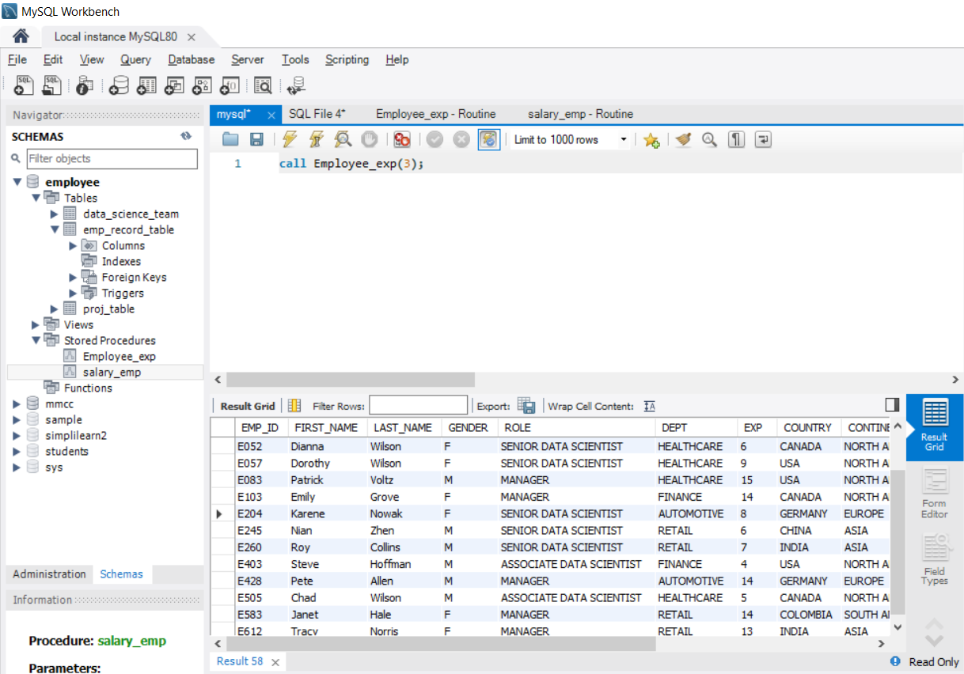

14.Write a query using stored functions in the project table to check whether the job profile assigned to each employee

in the data science team matches the organization’s set standard.

The standard being:

For an employee with experience less than or equal to 2 years assign 'JUNIOR DATA SCIENTIST',

For an employee with the experience of 2 to 5 years assign 'ASSOCIATE DATA SCIENTIST',

For an employee with the experience of 5 to 10 years assign 'SENIOR DATA SCIENTIST',

For an employee with the experience of 10 to 12 years assign 'LEAD DATA SCIENTIST',

For an employee with the experience of 12 to 16 years assign 'MANAGER'.

CREATE DEFINER=`root`@`localhost` PROCEDURE `Emp_role`(OUT Employee_ROLE varchar(255))

BEGIN

DECLARE Employee_ROLE VARCHAR(40);

IF EXP>12 AND 16 THEN

SET Employee_ROLE="MANAGER";

ELSEIF EXP>10 AND 12 THEN

SET Employee_ROLE ="LEAD DATA SCIENTIST";

ELSEIF EXP>5 AND 10 THEN

SET Employee_ROLE ="SENIOR DATA SCIENTIST";

ELSEIF EXP>2 AND 5 THEN

SET Employee_ROLE ="ASSOCIATE DATA SCIENTIST";

ELSEIF EXP<=2 THEN

SET Employee_ROLE ="JUNIOR DATA SCIENTIST";

END IF;

END

SELECT emp_exp,Employee_ROLE(emp_exp) as Employee_role

FROM data_science_team;

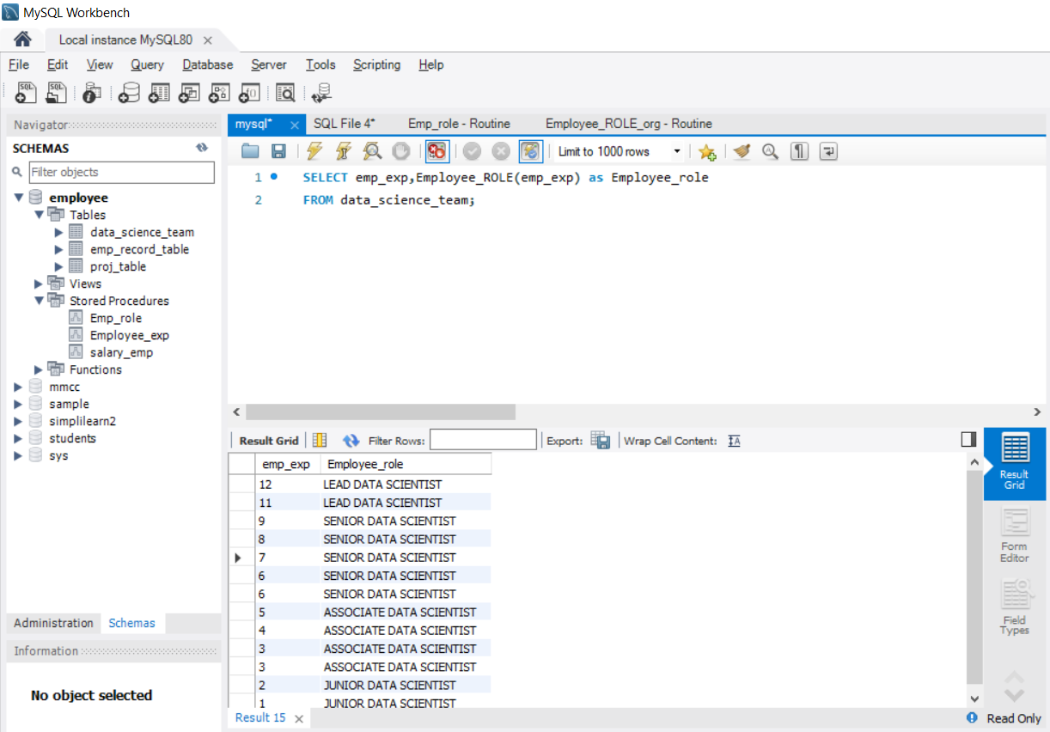

15.Create an index to improve the cost and performance of the query to find the employee whose FIRST_NAME is ‘Eric’ in the employee table after checking the execution plan.

create index first_name_index on emp_record_table(FIRST_NAME);

show index from emp_record_table;

select * from emp_record_table where FIRST_NAME = 'Eric';

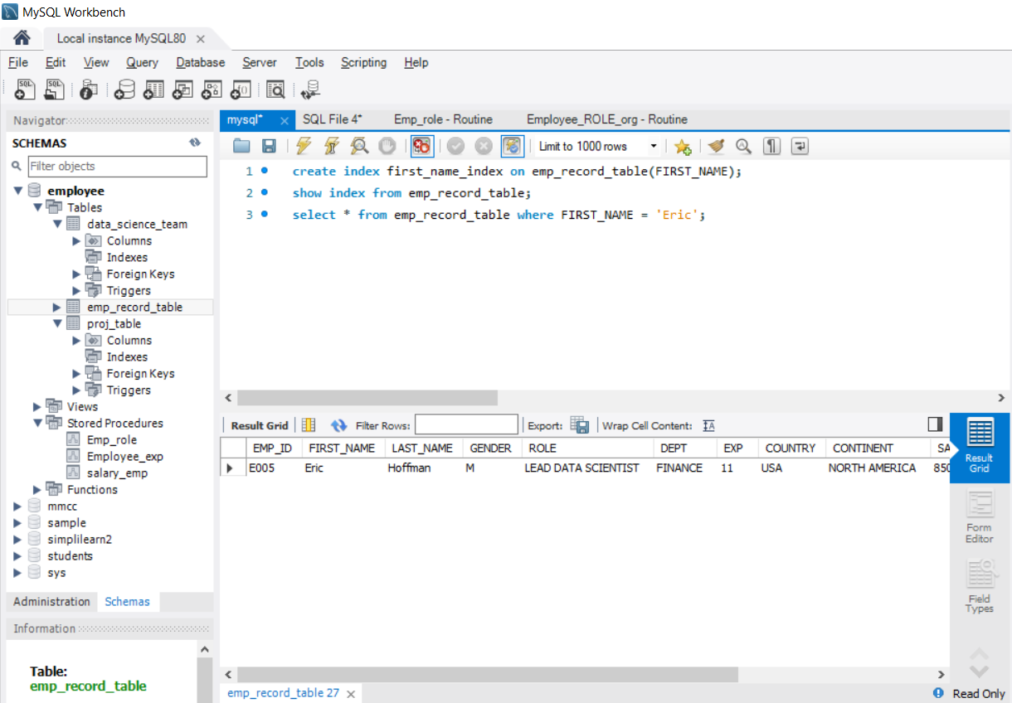

16.Write a query to calculate the bonus for all the employees, based on their ratings and salaries (Use the formula: 5% of salary * employee rating).

select concat(FIRST_NAME," ", LAST_NAME) as Emp_name, SALARY, EMP_RATING, (((5/100) * SALARY) * EMP_RATING) as Bonus from emp_record_table;

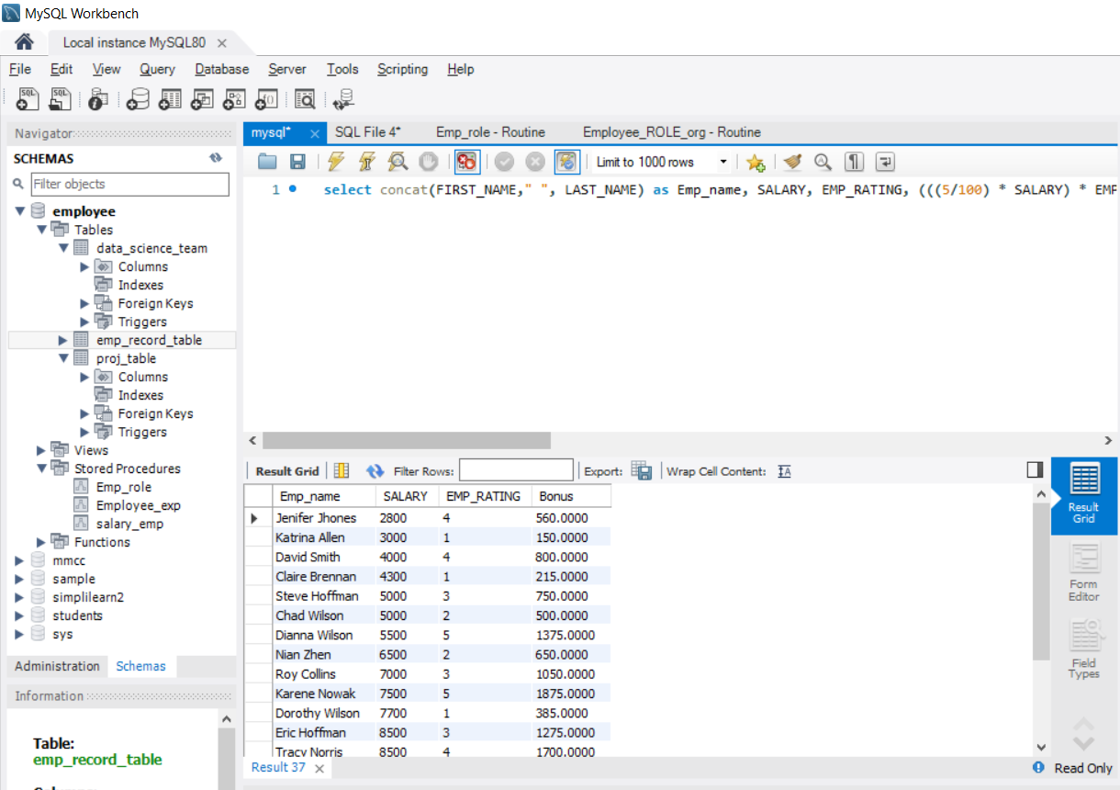

17.Write a query to calculate the average salary distribution based on the continent and country. Take data from the employee record table.

select CONTINENT, COUNTRY, Avg(SALARY) as Average_Salary from emp_record_table group by CONTINENT, COUNTRY;

